

**Box Game**

|  |  |  |
| --- | --- | --- |
| **Supervisor:** | *LÊ THANH NHÂN* | |
| **Semester:** | *II* | |
| **Batch No:** | *T1.2112.E0* | |
| **Group No:** | *IV* | |
| **Order:** | **Full name** | **Roll No.** |
| *1.* | *Nguyễn Tuấn Lộc* | *Student1350801* |
| *2.* | *Nguyễn Gia Bảo* | *Student1347086* |
| *3.* | *Nguyễn Phước Hoàn* | *Student1347090* |
| *4.* | *Nguyễn Lê Thanh Tùng* | *Student1350318* |
| *5.* | *Nguyễn Công Hùng* | *Student987459* |

***Month****: October* ***Year****: 2022*



This is to certify that

|  |  |
| --- | --- |
| **Mr.** | **Nguyễn Tuấn Lộc** |
| **Mr.** | **Nguyễn Gia Bảo** |
| **Mr.** | **Nguyễn Phước Hoàn** |
| **Mr.** | **Nguyễn Lê Thanh Tùng** |
| **Mr.** | **Nguyễn Công Hùng** |

Have successfully Designed & Developed

|  |  |  |
| --- | --- | --- |
|  |  |  |
|  | | |

Submitted by:

|  |
| --- |
| **Mr. LE THANH NHAN** |

Date Of Issue:

|  |  |
| --- | --- |
|  |  |

Authorized Signature:

|  |  |
| --- | --- |
|  |  |
| **Content** | | | |

Content

Acknowledge

Synposis

Review1 1

Review2 5

Review3 18

Testing Document 35

Final Checklist 36

Tasksheet 37

|  |
| --- |
| **Acknowledge** |

In the process of graduation, we have received a lot of help, suggestions, and enthusiastic advice from our teachers, family and friends. We sincerely thank Aptech Education for bringing the experience as well as practical skills in the project to bring us.

We would like to thank Mr Le Thanh Nhan, a teacher of FPT Aptech for always being dedicated and professional. Without the knowledge and experience of her superior, this project will not succeed.

And we sincerely thank the families of our team members for their great enthusiasm and support during the project.

This project is also successful thanks to the cooperation of the team members. Thank you.

|  |
| --- |
| **Synposis** |

Box Game is a online store that deals with all types of game. They started off with a company in collaboration with Ubisoft and then build up their own establishment. They have different game from different developer, special sale and promotion around the year. Many times people emails us in the website for getting the information as:

1. Minimum system requriements for specific game ?

2. Sale details ?

3. Price list for the games ?

4. What about the refund of the game?

And many more like these. You are supposed to create a website for them with the below mentioned requirement specifications: The website is to be developed to provide certain features according to specific requirements by the management. The website is to be developed for the Windows Platform using PHP, Laravel Framework, MySQL. The site should work well in all leading browsers including Chrome, IE, Firefox etc.

**Review 01**

|  |
| --- |
| **Problem Definition** |

1. **Introduction**

The development of Information Technology and Internet help users access information, communication, transaction or shopping are so easily. With the rise of technology, Electronic Commerce has become a way to carry out the business transactions faster, more convenient, reduce cost for maintenance and employees.

With the price increasement of products with the technology development, we bring to the customer a competitive environment to get the product with lowest price.

1. **Main Functions**
   * Visitor can view, order game after registering and logging in to the website. The product will be ship immediately through user email.
   * User can view all game as well as submit game reviews, edit profiles.
   * Store admins manage the game and orders.

|  |
| --- |
| **Customer Requirements Specifications** |

1. **Customer’s Specific Requirements**

The website allow user register and login to become member, which can use all the function of the website like review product, pay for the order online.

1. **Functional Requirements**

User:

• Input:

- Register information of users

- Purchase information

- Send feedback

• Process:

- Check register information

- Find products information

- Create orders

- Save feedback

• Output:

- Successfully registered notification

- Cart information

- Successfully send feedback notification

Admin:

• Input:

- Login information of admin account

- Add/update products request

- Add/update category

- View/delete user account request

• Process:

- Check login information of admin account

- Add/update products

- Add/update category

- Add/update system requirements

• Output:

- Successfully login notification

- Successfully add/update products

- Successfully add/update brands

- Successfully add/update/delete user account

**System Requirement Specification**

|  |  |
| --- | --- |
| Hardware: | Software: |
| Server:   * Pentium 4, 1.8 GHz or better * 512 MB of RAM * 300 MB of HDD capacities available   Client:   * Pentium III, 500 MHz * 265 MB of RAM | Server:   * OS with Windows XP SP2 * IE 5.0/Netscape 6.0 * MySQL Server 2008 or later Client: * IE 5.0/Netscape 6.0 |

**Development Software**

* Microsoft Windows 10
* Visual Studio Code
* MySQL
* Google Chrome

**Technology**

* *PHP 8.2*
* *Laravel Framework 9.2*

**Review 02**

|  |
| --- |
| **Data Flow Diagram** |

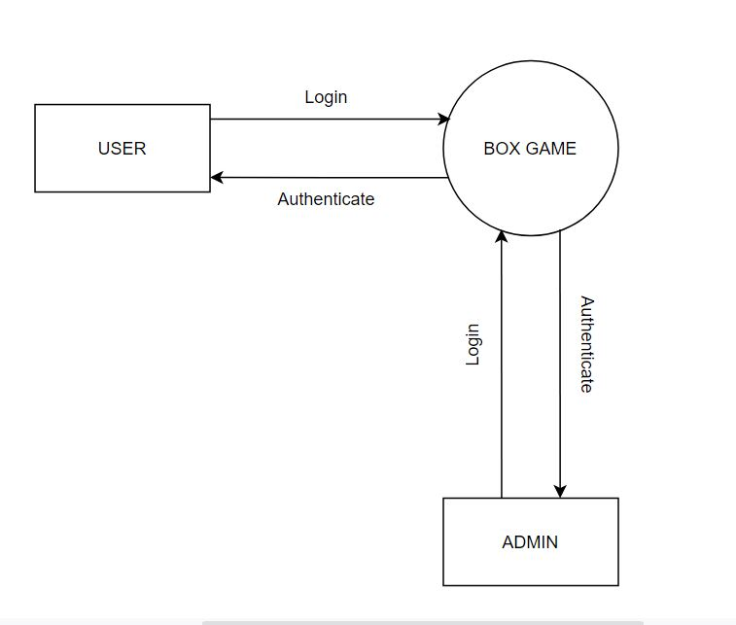

|  |
| --- |
| **A. Entity Relationship Diagram** |

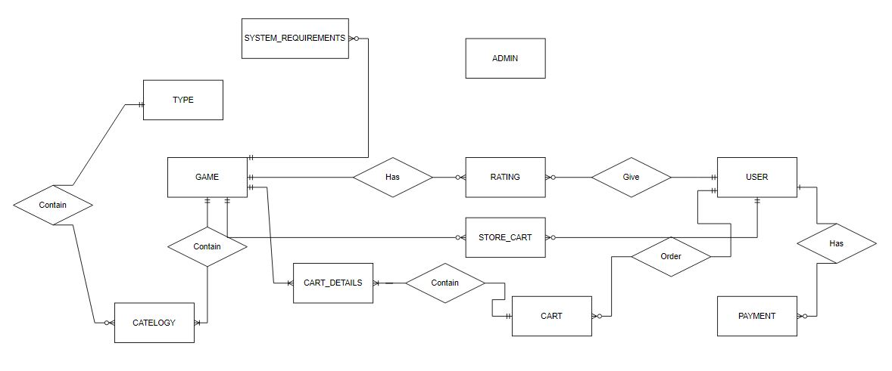

|  |
| --- |
| **B. Entity Attributes** |

1. USER

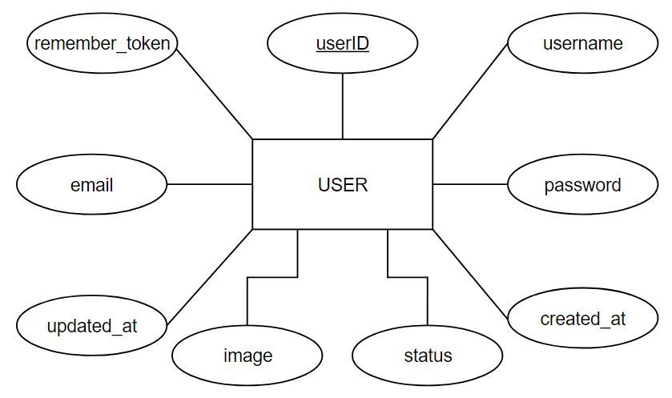

1. 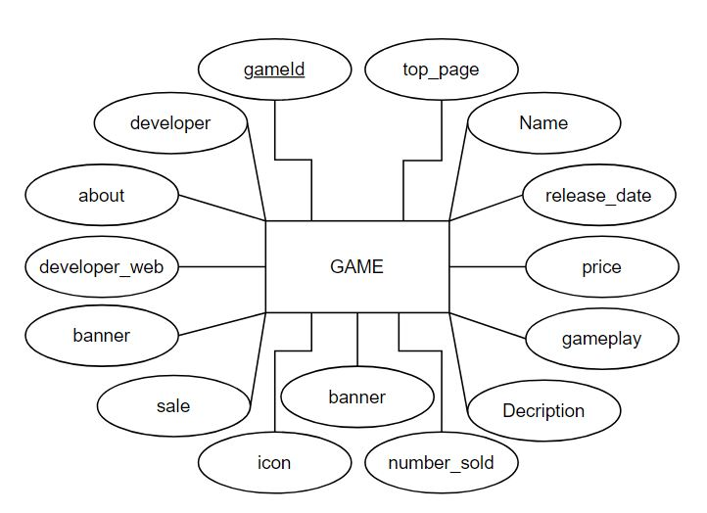GAME
2. ADMIN

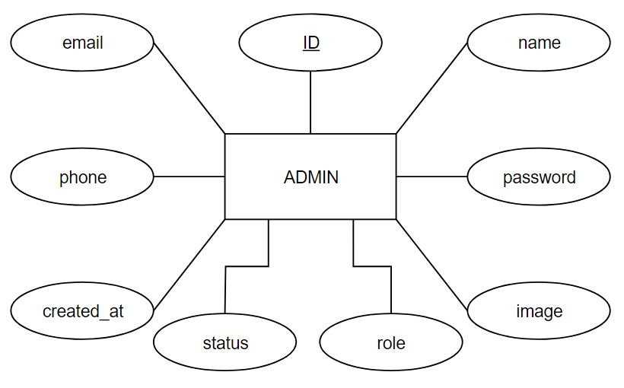

1. CART MASTER AND DETAILS

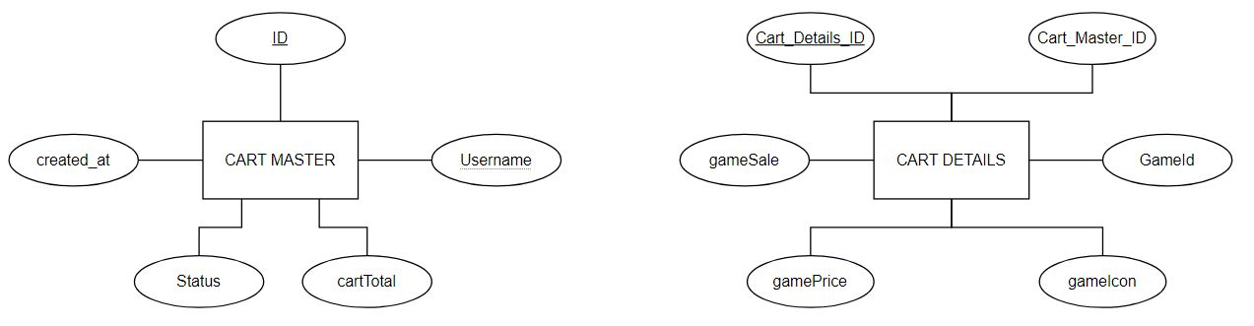

1. CATELOGY AND TYPE

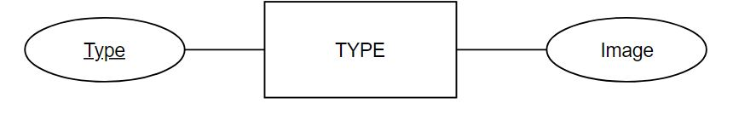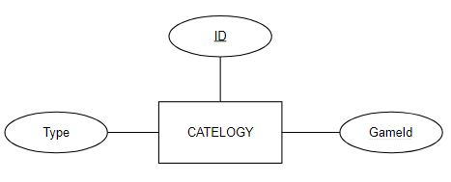

1. PAYMENT

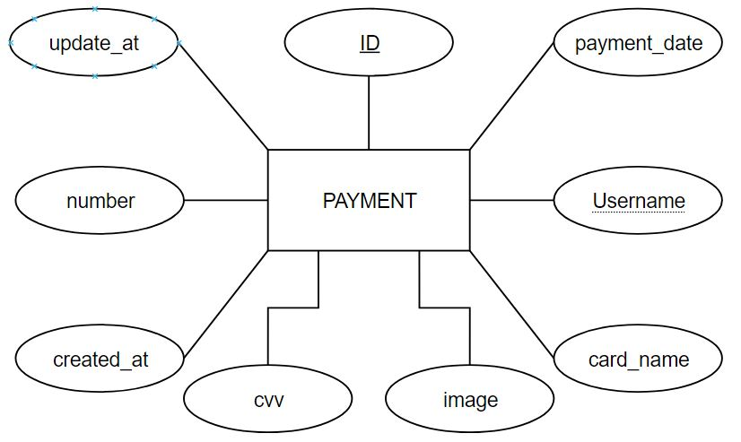

1. SYSTEM REQUIREMENTS

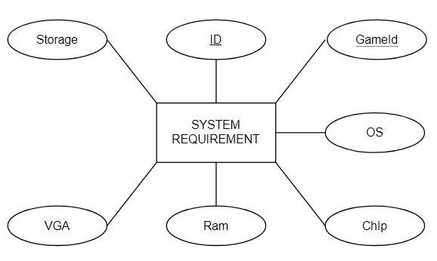

1. STORE CART

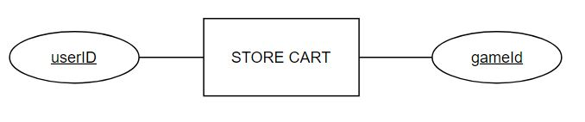

|  |
| --- |
| **C. Table Design** |

1. ACCOUNT_ADMIN

|  |  |  |  |  |  |
| --- | --- | --- | --- | --- | --- |
| No. | Column Name | Data Type | Keys | Constraints | Description |
| 1 | adminId | varchar(255) | Primary key | not null | login id |
| 2 | name | varchar(255) |  | not null | display name |
| 3 | email | varchar(255) |  | not null |  |
| 4 | password | varchar(255) |  | not null |  |
| 5 | role | varchar(255) |  | not nul |  |
| 6 | status | bit |  | not null | active or not |
| 7 | image | varchar(255) |  | not null |  |
| 8 | phone | int |  |  |  |
| 9 | create_at | timestamp |  | current_timestamp |  |
| 10 | update_at | timestamp |  | current_timestamp |  |

1. USERS

|  |  |  |  |  |  |
| --- | --- | --- | --- | --- | --- |
| No. | Column Name | Data Type | Keys | Constraints | Description |
| 1 | userID | varchar(255) | Primary key | not null | login id |
| 2 | username | varchar(255) |  | not null | display name |
| 3 | email | varchar(255) |  | not null |  |
| 4 | password | varchar(255) |  | not null |  |
| 5 | status | bit |  | not null | active or not |
| 6 | remember_token | varchar(100) |  | not null |  |
| 7 | image | varchar(255) |  |  |  |
| 8 | create_at | timestamp |  | current_timestamp |  |
| 9 | update_at | timestamp |  | current_timestamp |  |

1. GAME

|  |  |  |  |  |  |
| --- | --- | --- | --- | --- | --- |
| No. | Column Name | Data Type | Keys | Constraints | Description |
| 1 | gameId | int | Primary key | not null |  |
| 2 | name | varchar(255) |  | not null | display name |
| 3 | description | varchar(1000) |  | not null |  |
| 4 | gameplay | varchar(100) |  | not null | gameplay image |
| 5 | icon | varchar(255) |  | not null | game icon |
| 6 | release_date | datetime |  | not null |  |
| 7 | developer | varchar(255) |  | not null |  |
| 8 | developer_web | varchar(255) |  |  |  |
| 9 | create_at | timestamp |  | current_timestamp |  |
| 10 | sale | int |  | default 0 |  |
| 11 | about | varchar(2000) |  |  |  |
| 12 | number_sold | int(100) |  |  |  |
| 13 | top_page | bit(1) |  | default 0 | for display on top main page |
| 14 | banner | varchar(255) |  | not null | game banner |
| 15 | most_played | bit(1) |  | default 0 |  |

1. RATING

|  |  |  |  |  |  |
| --- | --- | --- | --- | --- | --- |
| No. | Column Name | Data Type | Keys | Constraints | Description |
| 1 | gameId | int | Primary key, Foreign Key | not null |  |
| 2 | userId | varchar(255) | Primary key, Foreign Key | not null |  |
| 3 | star | int |  | not null | rating star |
| 4 | message | varchar(1000) |  |  | comment |
| 5 | create_at | timestamp |  | current_timestamp |  |

1. PAYMENT

|  |  |  |  |  |  |
| --- | --- | --- | --- | --- | --- |
| No. | Column Name | Data Type | Keys | Constraints | Description |
| 1 | cardId | int | Primary key | not null |  |
| 2 | userID | varchar(255) | Foreign Key | not null |  |
| 3 | number | int |  | not null | card number |
| 4 | cvv | int(3) |  | not null | security number |
| 5 | payment_date | datetime |  | not null | expired date |
| 6 | card_name | varchar(255) |  | not null |  |
| 7 | image | varchat(255) |  | not null |  |
| 8 | updated_at | timestamp |  | current_timestamp() |  |
| 9 | created_at | timestamp |  | current_timestamp() |  |

1. CATEGORY

|  |  |  |  |  |  |
| --- | --- | --- | --- | --- | --- |
| No. | Column Name | Data Type | Keys | Constraints | Description |
| 1 | categoryId | int | Primary key | not null |  |
| 2 | gameId | int | Foreign Key | not null |  |
| 3 | type | varchar(255) | Foreign Key | not null | game type |

1. CART MASTER

|  |  |  |  |  |  |
| --- | --- | --- | --- | --- | --- |
| No. | Column Name | Data Type | Keys | Constraints | Description |
| 1 | cartId | int | Primary key | not null |  |
| 2 | userId | varchar(255) | Foreign Key | not null |  |
| 3 | status | bit |  |  | check if cart paid or not |
| 4 | cartTotal | float |  | default 0 |  |
| 5 | created_at | timestamp |  | current_timestamp() |  |

1. CART DETAILS

|  |  |  |  |  |  |
| --- | --- | --- | --- | --- | --- |
| No. | Column Name | Data Type | Keys | Constraints | Description |
| 1 | cart_details_id | int | Primary key | not null |  |
| 2 | gameId | varchar(255) | Foreign Key | not null |  |
| 3 | cartId | varchar(255) | Foreign Key | not null |  |
| 4 | gameSale | int |  | not null |  |
| 5 | gamePrice | float |  | not null |  |
| 6 | gameIcon | varchar(255) |  | not null |  |

1. SYSTEM REQUIREMENTS

|  |  |  |  |  |  |
| --- | --- | --- | --- | --- | --- |
| No. | Column Name | Data Type | Keys | Constraints | Description |
| 1 | sysId | int | Primary key | not null |  |
| 2 | gameId | varchar(255) | Foreign Key | not null |  |
| 3 | os | varchar(255) |  | not null | OS system |
| 4 | storage | varchar(255) |  | not null |  |
| 5 | chip | varchar(255) |  | not null | chipset |
| 6 | graphic | varchar(255) |  | not null | vga |

1. TYPE

|  |  |  |  |  |  |
| --- | --- | --- | --- | --- | --- |
| No. | Column Name | Data Type | Keys | Constraints | Description |
| 1 | type | varchar(255) | Primary key | not null |  |
| 2 | image | varchar(255) |  |  |  |

1. STORE CART

|  |  |  |  |  |  |
| --- | --- | --- | --- | --- | --- |
| No. | Column Name | Data Type | Keys | Constraints | Description |
| 1 | userID | varchar(255) | Primary key | not null |  |
| 2 | gameId | varchar(45) | Primary key | not null |  |

|  |
| --- |
| **D. Relationship Diagram** |

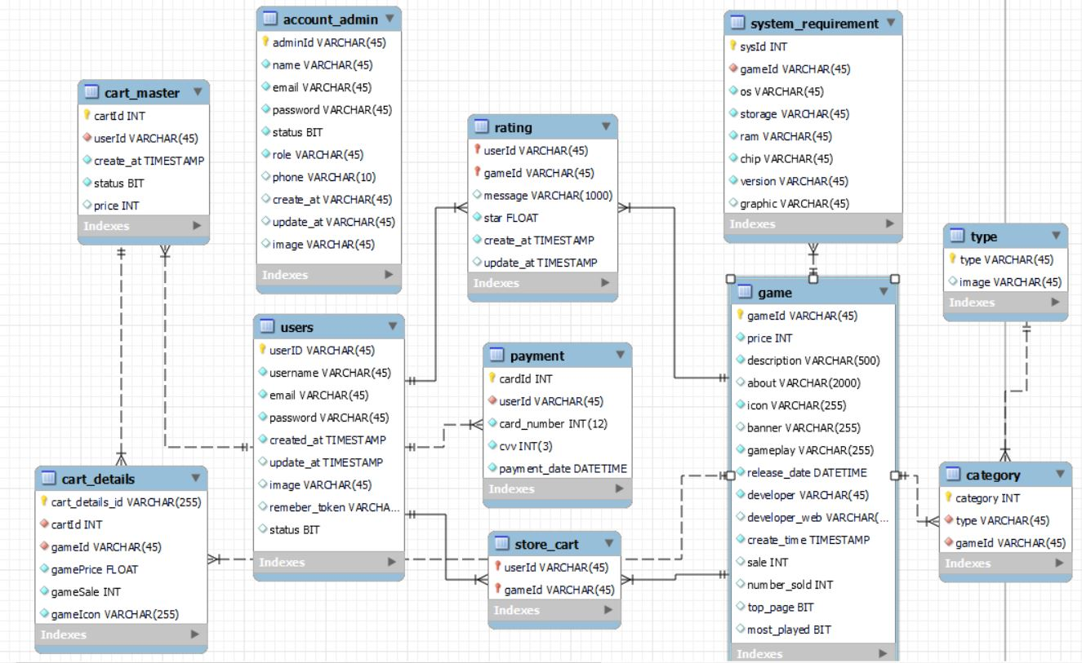

|  |
| --- |
| **Site Map** |

1. USER

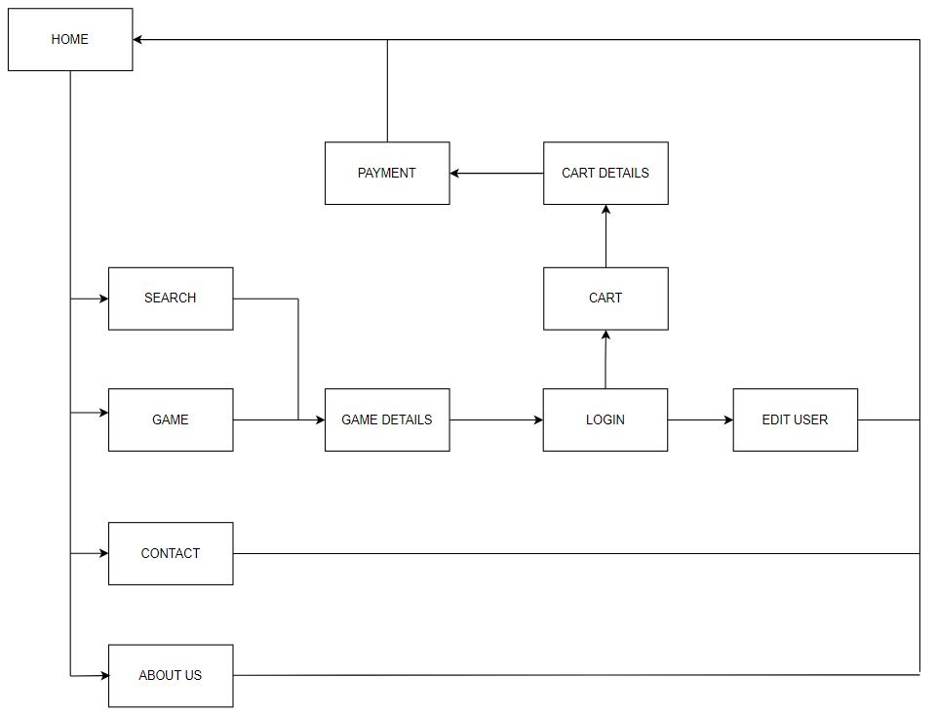

1. ADMIN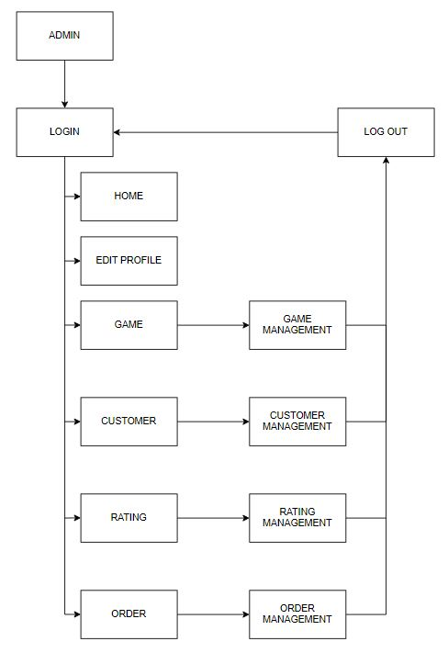

|  |
| --- |
| **Algorithm** |

1. USER

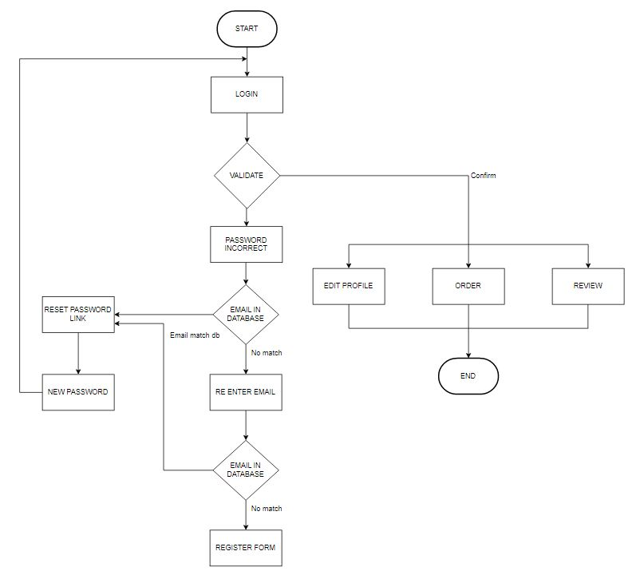

1. ADMIN

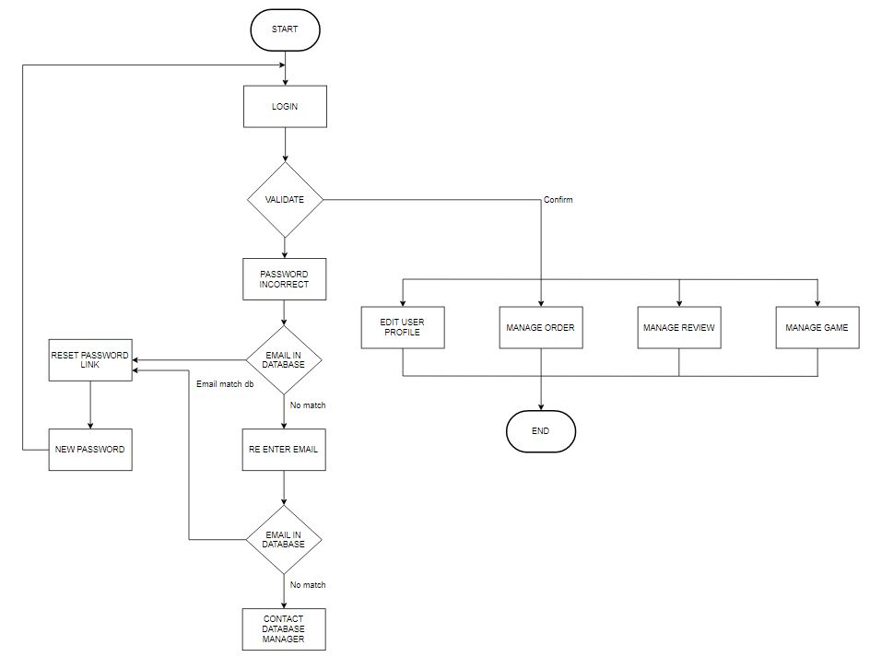

**Review 03**

|  |
| --- |
| **Screen shots** |

1. Login Page:

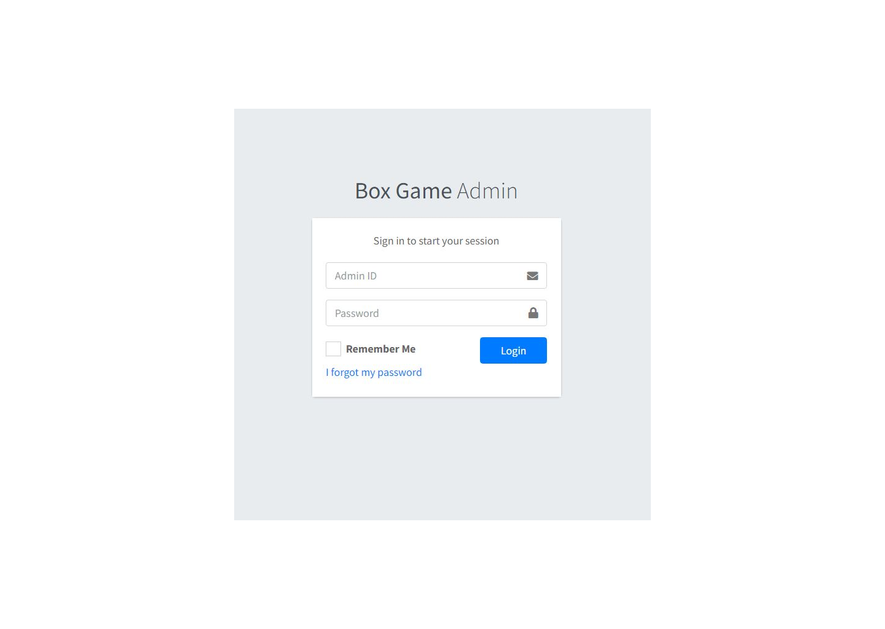

**Description** : Login for Admin

**From** : From start page with /admin

**To** : Admin Front Page

1. Admin Front Page

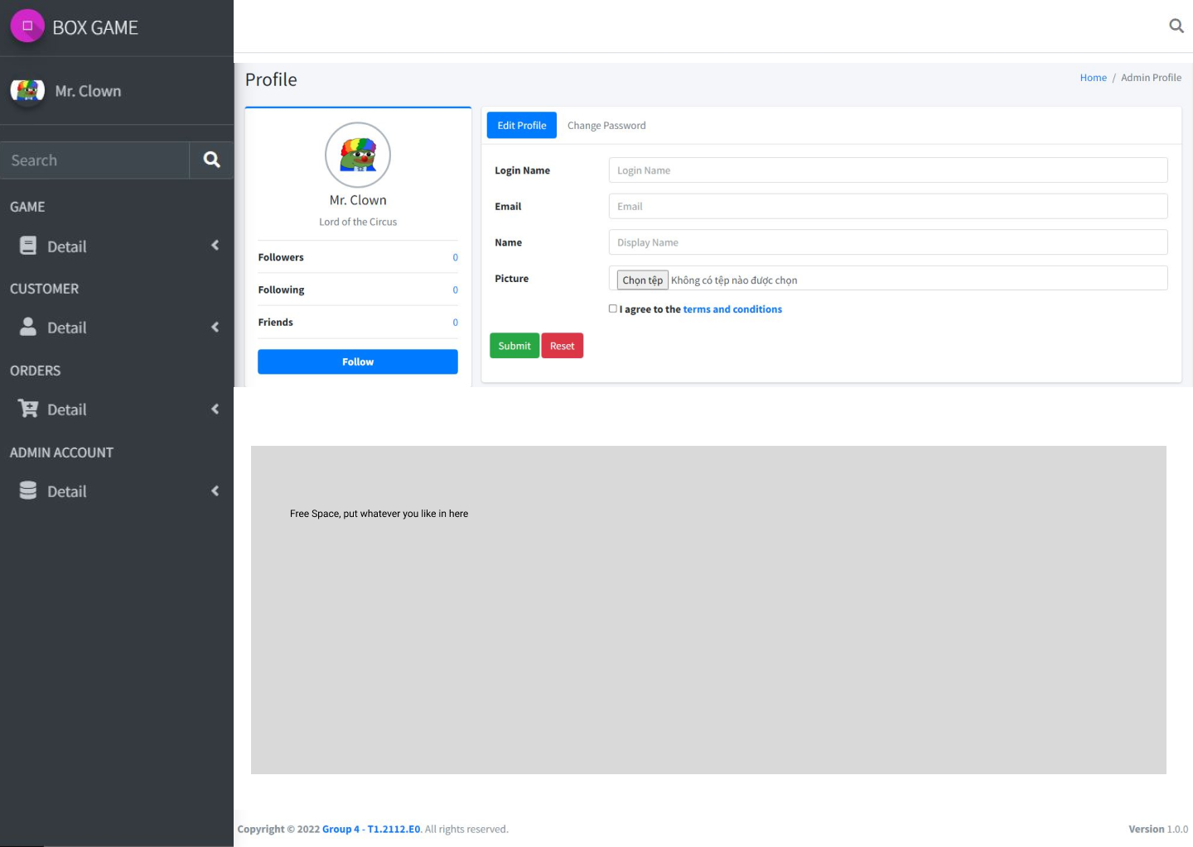

**Description** : Login Front Page

**From** : After login successfully

**To** : Game, User, Orders management, edit admin own profile or password through forms in the front page

1. Admin All Game

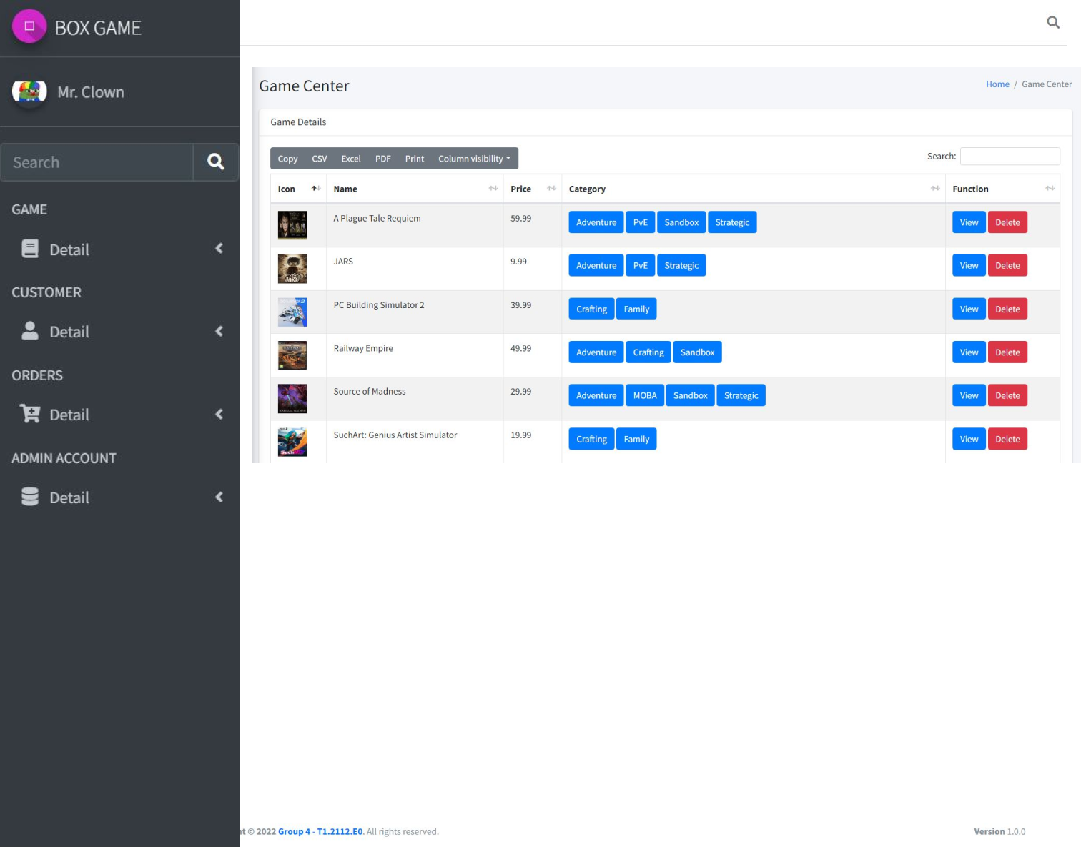

**Description** : Admin view all game in database

**From** : Side Bar

**To** : View detail game, delete game

1. Admin Edit Game

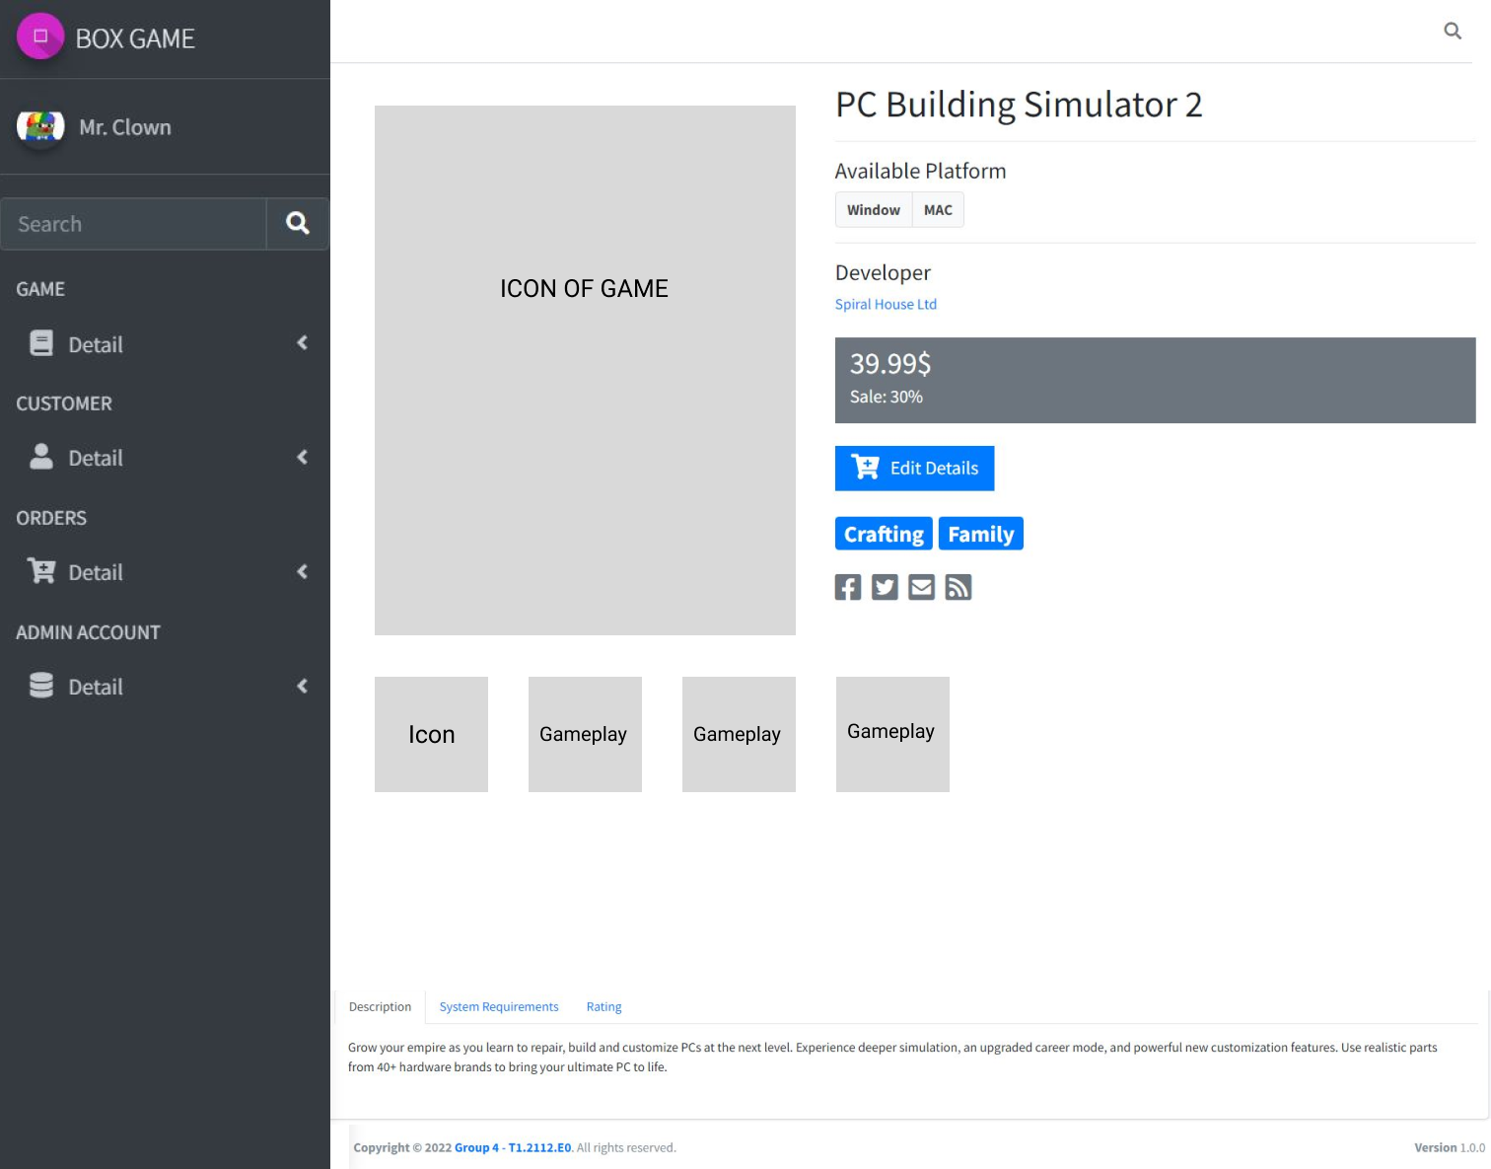

**Description** : Detail of game

**From** : View all game, after click view button

**To** : Edit game, system requirement, category, return home

1. Admin Add Game

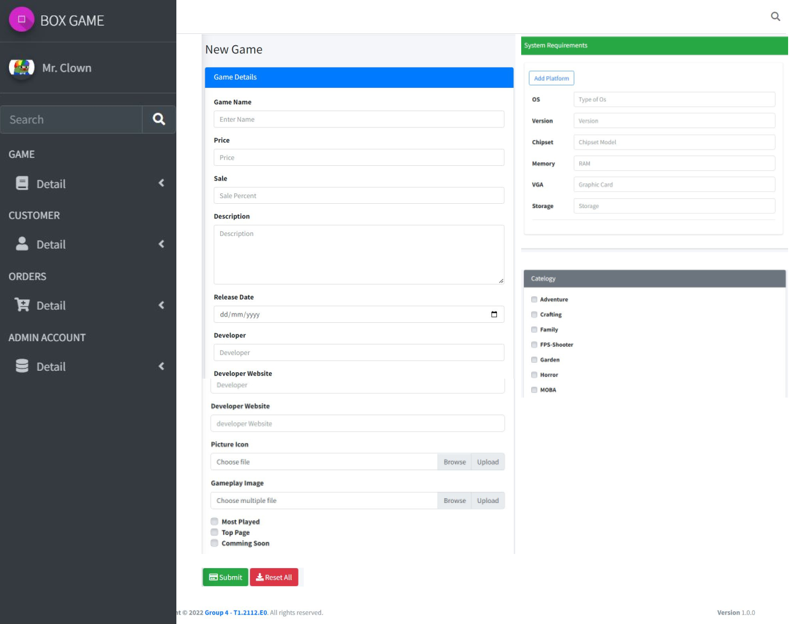

**Description** : Add new game to database

**From** : Side bar, game section

**To** : After submit form, if success return to detail page of new game, or return to create game form with error message

1. Admin Edit Category

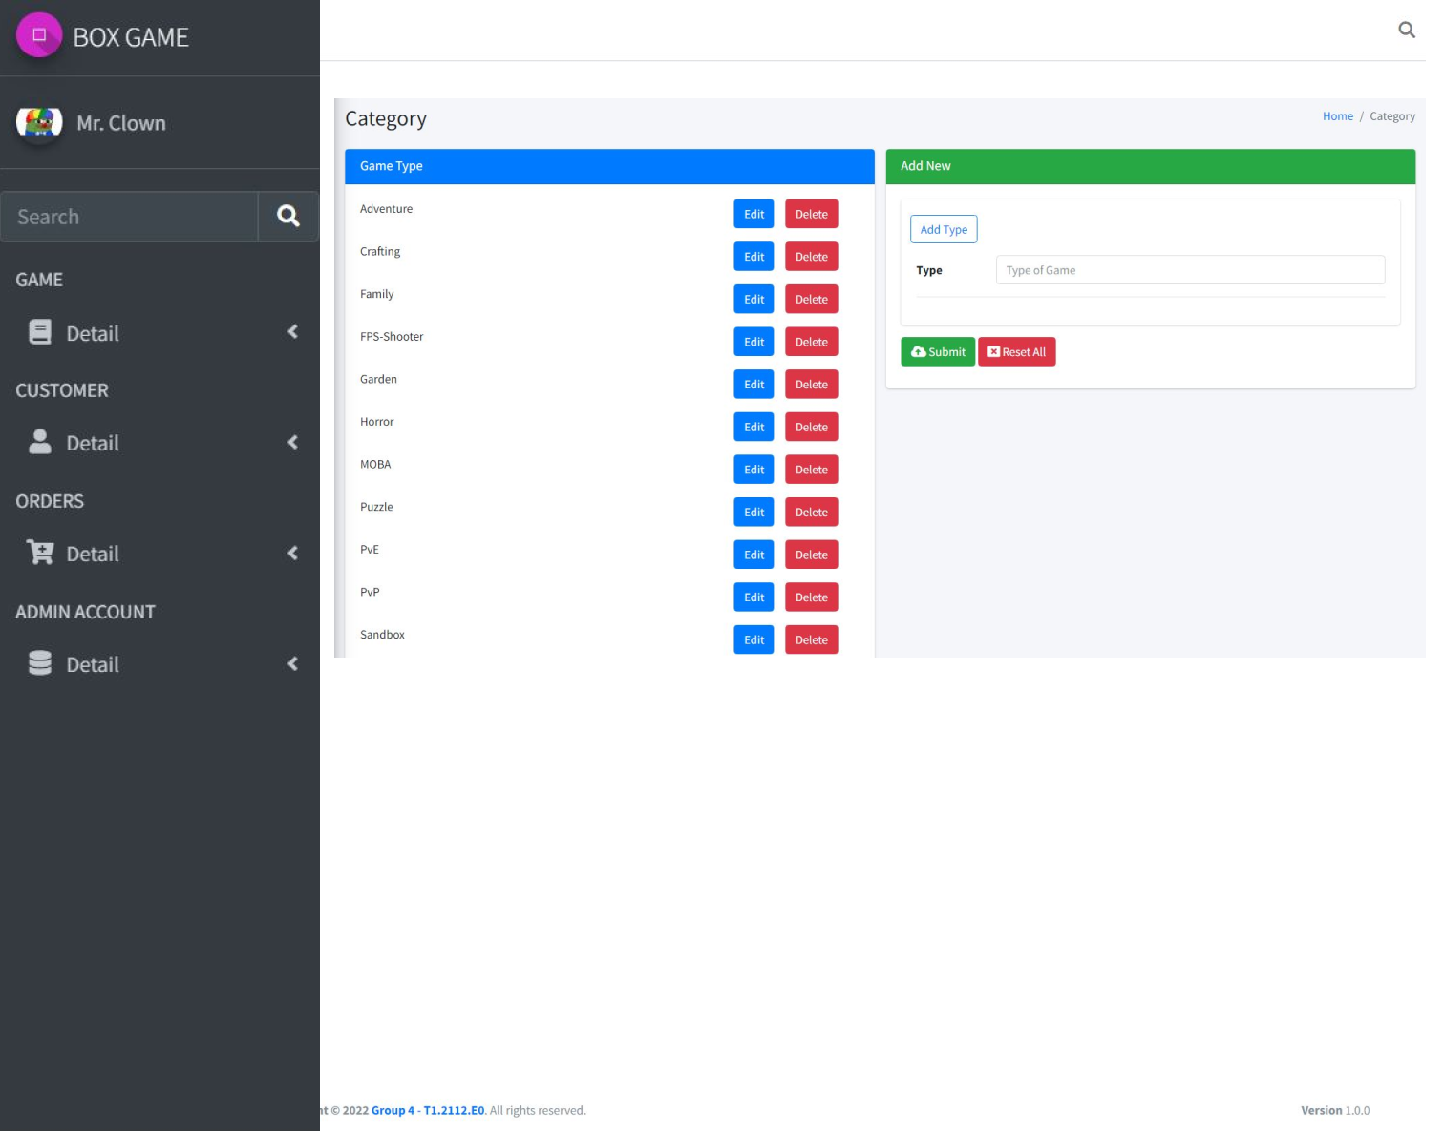

**Description** : Category

**From** : Side bar, game section

**To** : Edit type or add new, or return admin front page

1. Admin User Management

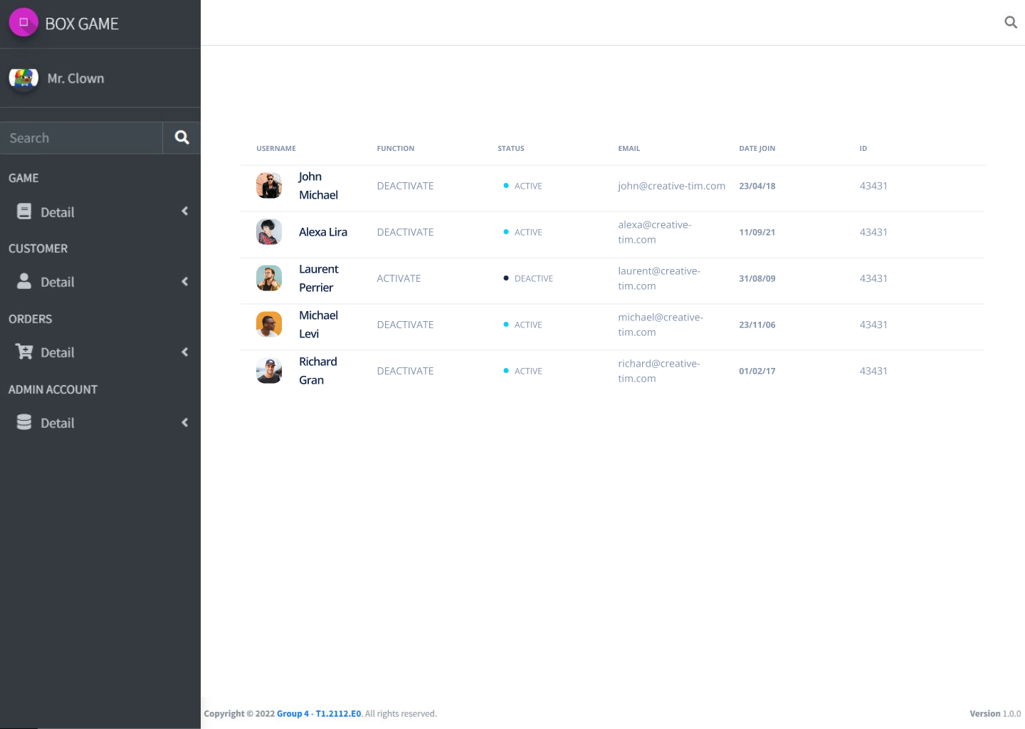

**Description** : Admin view all user

**From** : Side bar, user section

**To** : Return home or edit user status

1. Admin Order Details

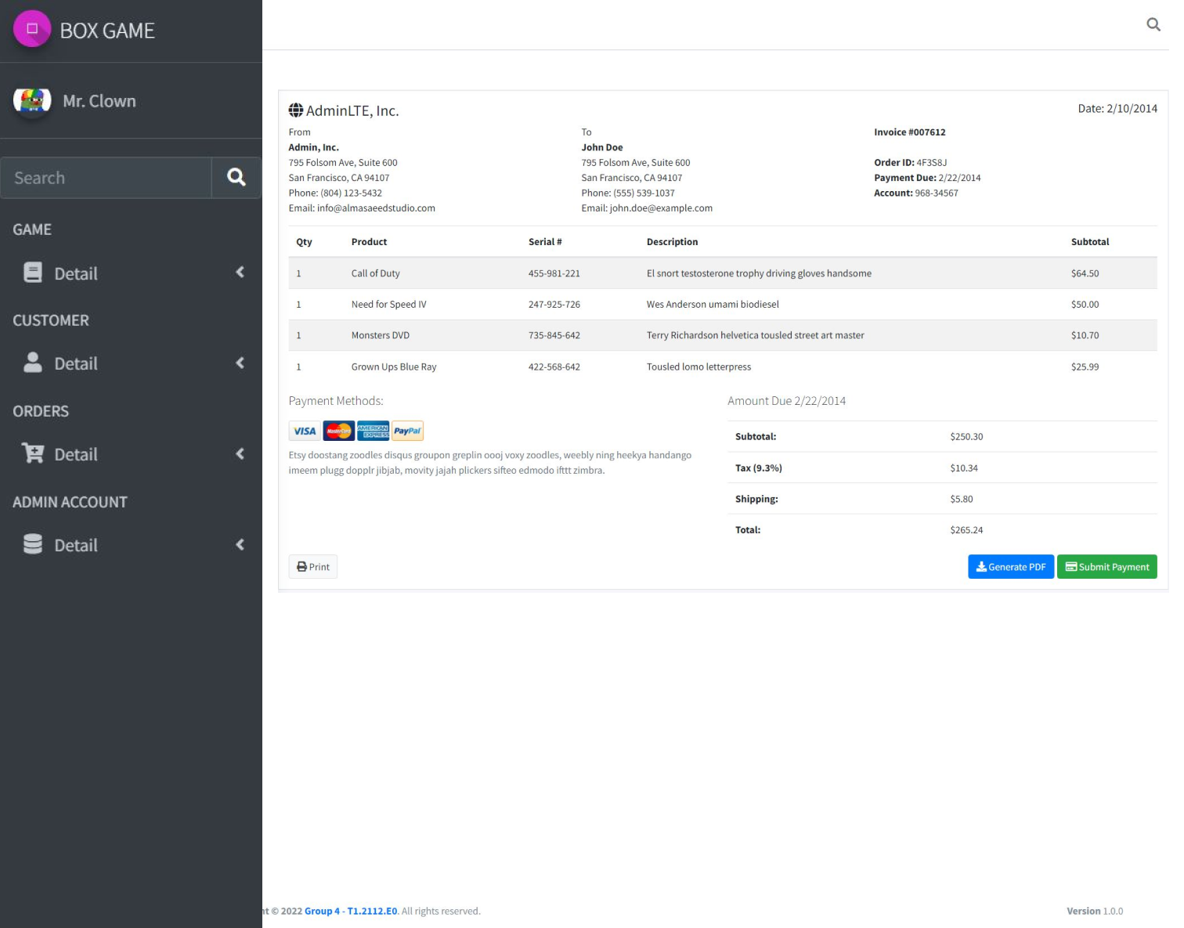

**Description** : Orders detail of user

**From** : Side bar, order section

**To** : Print invoice, send to email or return home

1. NavBar Details

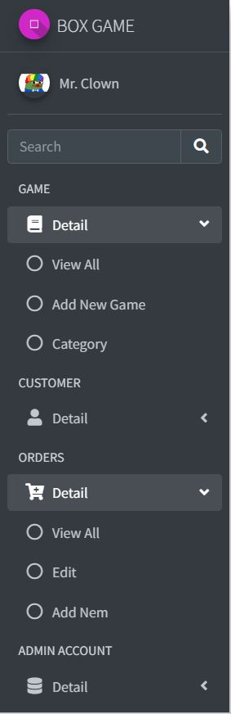

**Description** : Side bar

**From** : After login successfully

**To** : Game, User, Orders management

1. Main Page

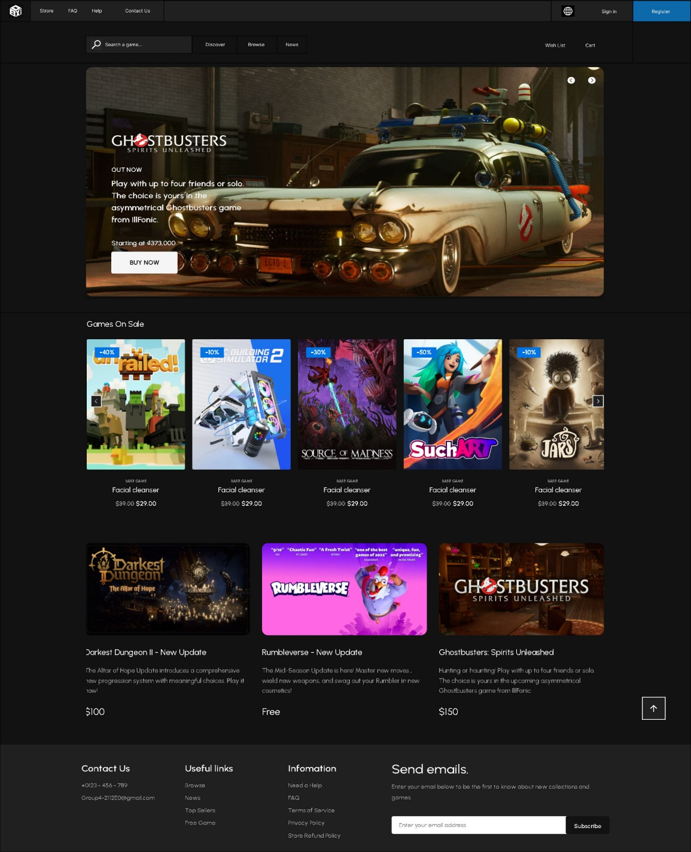

**Description** : Main web page

**From** : After click URL

**To** : Game detail, add to cart, browse category, login, contact,….

1. 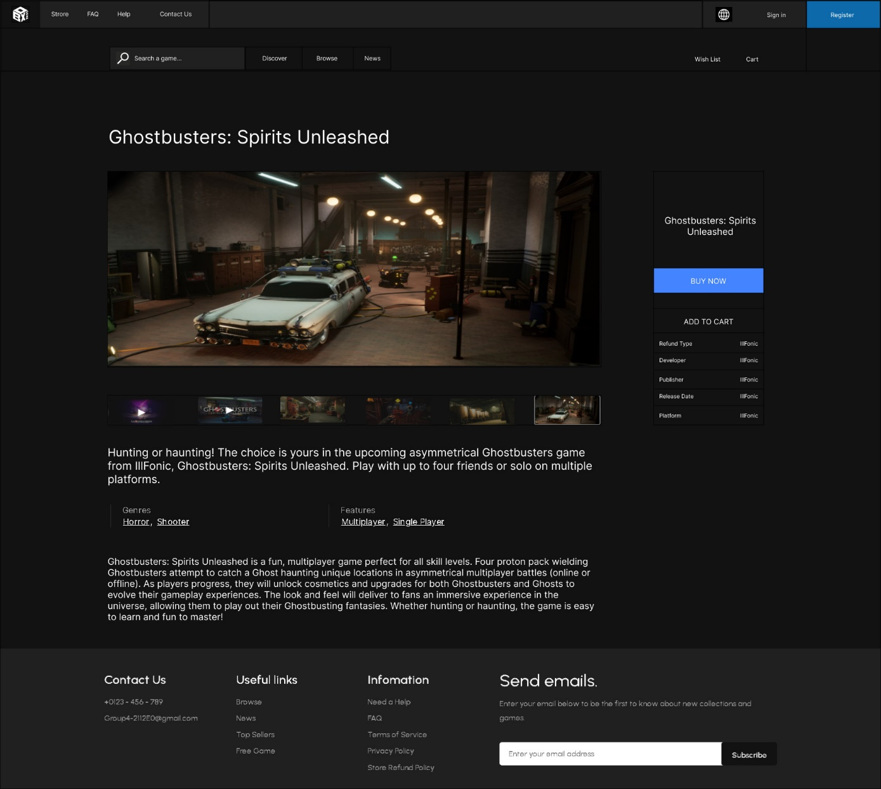Game Detail

**Description** : Detail of game

**From** : Home, after click picture or game name

**To** : Add to cart or return home

1. User Login, Register and Forget Password

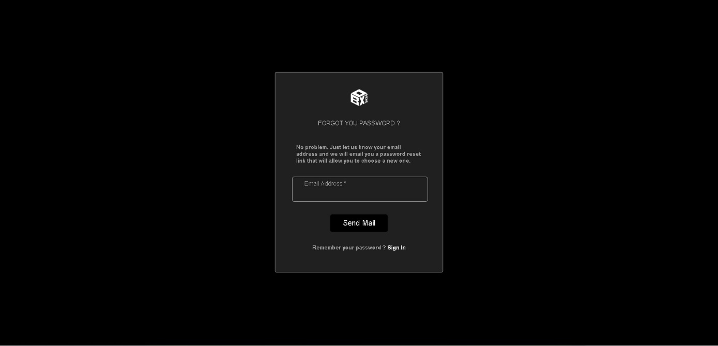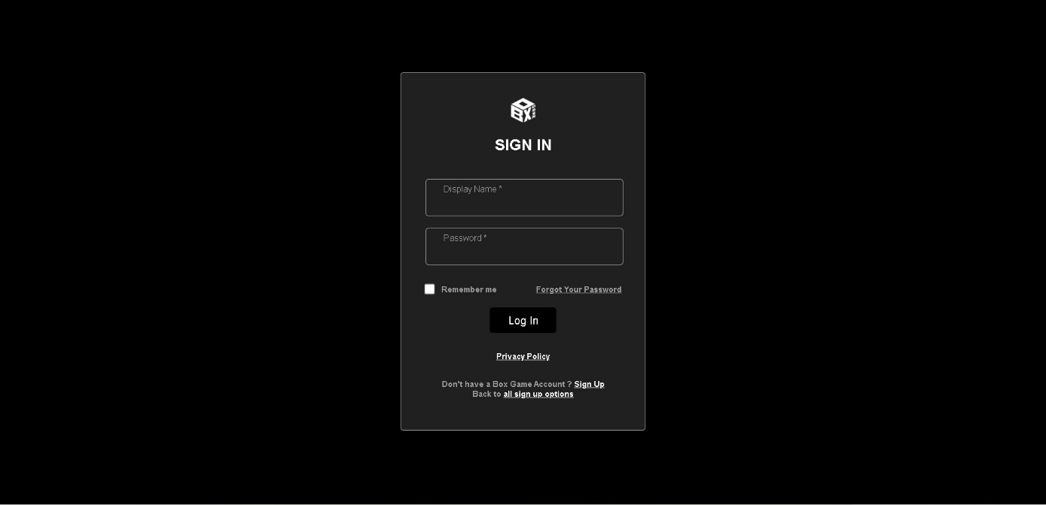

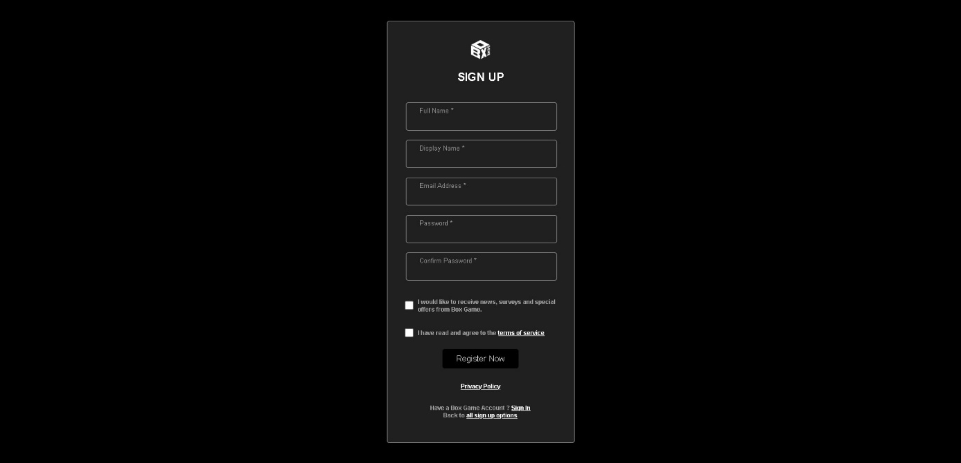

**Description** : User form

**From** : Home, login button or add to cart if not login

**To** : Anywhere in page for login, turn back home when recover password

1. Cart Detail

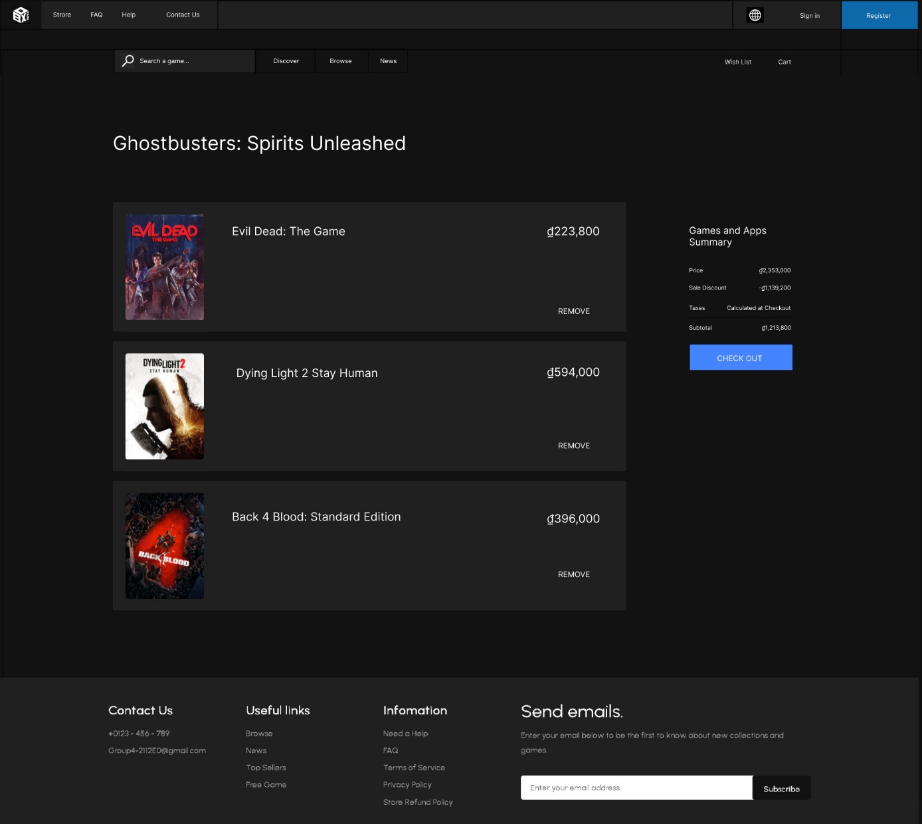

**Description** : Cart detail of user

**From** : Home, button cart after login

**To** : Process to payment or return home

1. 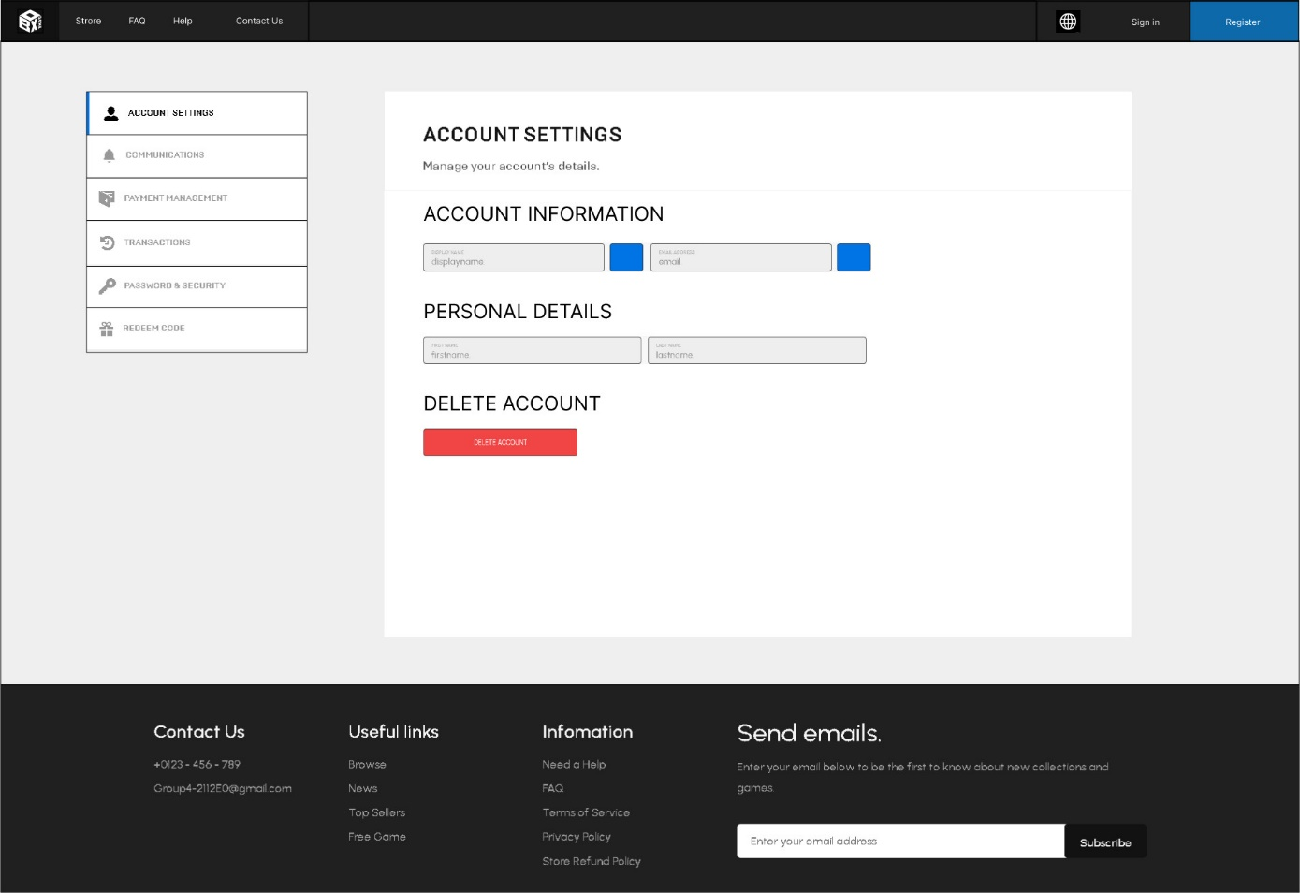User Profile Edit

**Description** : Edit profile of user

**From** : Home, button username top page after login

**To** : Edit account or return home

1. Browse Category

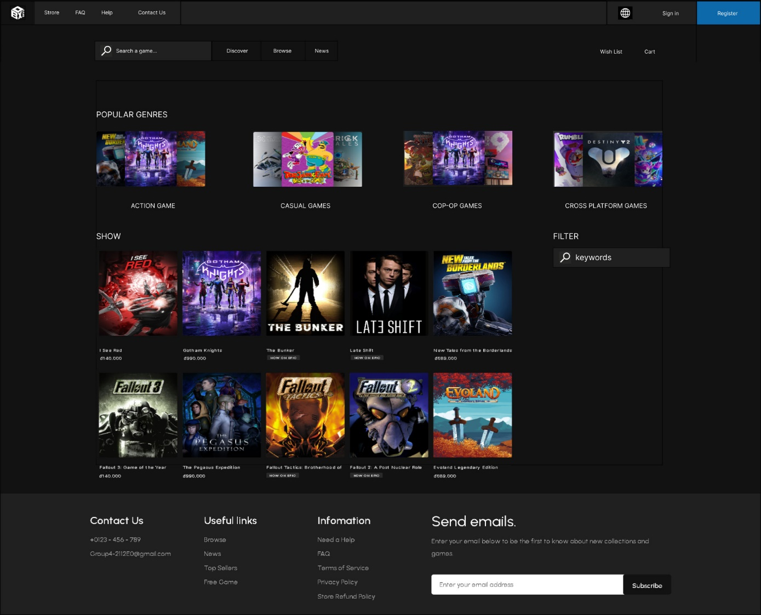

**Description** : Category

**From** : Home, browse in top page

**To** : Game detail by click to game image or return home

|  |
| --- |
| **Testing document** |

|  |  |  |
| --- | --- | --- |
| **Sr.No** | **Features Tested** | **Remarks** |
| 1 | The Home Page should be neatly created with proper logo, menu and images. |  |
| 2 | A menu which will include all the functions implemented in the site. |  |
| 3 | A catalogue should be provided which will help the users to have a look. |  |
| 4 | The user should be able to search the game based on name and type. |  |
| 5 | Admin should be able to add mutiple game image |  |
| 6 | Admin should be able to edit game info |  |
| 7 | Does the Web page take too long to be loaded fully? |  |
| 8 | Are all the forms validated with proper criteria? |  |
| 9 | All image should be clearly see from page |  |
| 10 | Proper message for each error |  |
| 11 | All functions should working correctly |  |
| 12 | Check spelling error |  |
| 13 | Admin has to login first |  |

|  |
| --- |
| **Final checklist** |

|  |  |  |
| --- | --- | --- |
| **Sr.No** | **Aspected Tested** | **Suggestion/**  **Remarks** |
| 1 | Are all the users able to view the images and links? |  |
| 2 | Have all the views, modules and controllers been properly integrated and is the site function as a single page application? |  |
| 3 | Are the GUI content devoid of spelling mistakes? |  |
| 4 | Is the application user-friendly? |  |
| 5 | Is the Website launching correctly in all popular browsers? |  |
| 6 | Are all the forms validated with proper criteria? |  |
| 7 | Do all text links lead to the appropriate website? |  |
| 8 | Do all image links lead to the appropriate website? |  |
| 9 | Are all the images and links clearly visible on the page? |  |
| 10 | Does the Web page work properly in all the tested browsers? |  |
| 11 | Does the Web page take too long to be loaded fully? |  |
| 12 | Is the navigation sequences correct through all the Web pages on the site? |  |
| 13 | Is the JavaScript code working as expected in all click events? |  |

|  |  |  |  |  |  |  |  |  |
| --- | --- | --- | --- | --- | --- | --- | --- | --- |
| **No** | **Member** | **Contents** | | **Table Name** | **Activity Plan** | **Date of Preparation of Activity Plan** | | |
| **Planed Start Date** | **Actual Start Date** | **Actual Days** | **Status** |
| 1 | **Nguyễn Tuấn Lộc** | Admin | *Edit Admin account, manage system requirement each game platform, manage type of game* | Account_admin, System_requirement,  Type | 12/10/2022 | 14/10/2022 | 2 | OK |
| 2 | 16/10/2022 | 16/10/2022 | 1 | OK |
| 3 | User | *Check system requirement* | 18/10/2022 | 18/10/2022 | 12 | OK |
| 4 | 31/10/2022 | 1/11/2022 | 12 | OK |
|  |  |  |  |  |  |  |  |  |
| 1 | **Nguyễn Gia Bảo** | Admin | *Order Management, check order status* | Cart_master, Cart_details,  Store_cart | 12/10/2022 | 14/10/2022 | 10 | OK |
| 2 | 01/11/2022 | 1/11/2022 | 10 | OK |
| 3 | 10/11/2022 | 10/11/2022 | 10 | OK |
| 4 | User | *Personal Order Management* | 10/11/2022 | 10/11/2022 | 5 | OK |
|  |  |  |  |  |  |  |  |  |
| 1 | **Nguyễn Phước Hoàn** | Admin | *Customer Management* | User, Payment | 12/10/2022 | 12/10/2022 | 10 | OK |
| 2 | 18/10/2022 | 19/10/2022 | 10 | OK |
| 3 | User | *Register* | 31/10/2022 | 31/10/2022 | 10 | OK |
| 4 | *Edit profile, Add payment* | 5/11/2022 | 5/11/2022 | 5 | OK |
|  |  |  |  |  |  |  |  |  |
| 1 | **Nguyễn Lê Thanh Tùng** | Admin | *Game Management, Add or Delete Category* | Game, Category | 12/10/2022 | 14/10/2022 | 5 | OK |
| 2 | 15/10/2022 | 15/10/2022 | 5 | OK |
| 3 | User | *View, Search Product* | 01/11/2022 | 31/10/2022 | 5 | OK |
| 4 | 01/11/2022 | 10/11/2022 | 5 | OK |
|  |  |  |  |  |  |  |  |  |
| 1 | **Nguyễn Công Hùng** | Admin | *Rating/Comment Management* | Rating | 01/10/2022 | 01/10/2022 | N/A | N/A |
| 2 | 01/10/2022 | 01/10/2022 | N/A | N/A |
| 3 | 01/10/2022 | 01/10/2022 | N/A | N/A |
| 4 | User | *Send rating, Comment* | 01/10/2022 | 01/10/2022 | N/A | N/A |